# Deleting a Maintenance Activity

A logging system for all the instruments on base was implemented in 2018. The logging scripts and data can be found on the data server. Any activities or disturbances to any of the instruments should be logged using this system.

Data that is entered using the logging script is synced with the instrument PC as well as being fed into the InfluxDB database. From there the log entries can then be displayed live on the Grafana dashboards and read into the monthly reports automatically.

In case an entry needs to be deleted, a separate script needs to be run. This script will then delete the entry from the data server, instrument PC and the InfluxDB database. This section provides detailed instructions for logging entries, deleting entries, and adding new systems.

## Instructions

To delete a faulty activity entry, run the script: del.sh and follow the instructions, as demonstrated by the following steps:

1. First, the script will display an enumerated list of all the registered systems. It will then prompt for an instrument number, corresponding to the instrument on which the activity is to be logged. Enter the number and then press the Enter key.

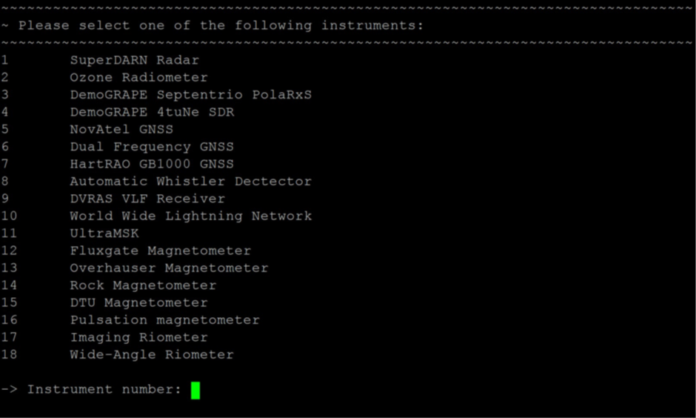

Figure . Deleting an activity: Step 1.

1. When asked for the date, once again a default value is displayed. The default date is that of the present day and if the event occurred on a previous day, that date should be entered in the correct format.

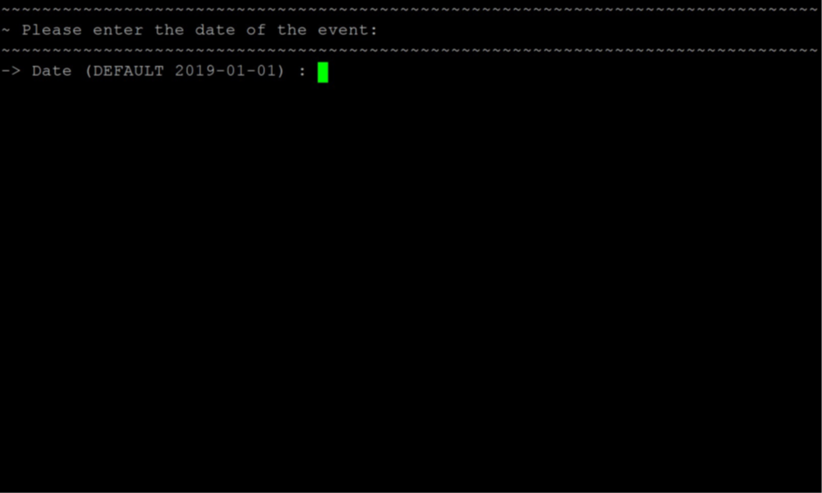

Figure . Deleting an activity: Step 2.

1. The script will then display an enumerated list of all the activities logged for the date previously specified. Enter the number corresponding to the faulty entry and press Entry to delete that entry. Wait for the logs to be synchronized with the instrument PC and influxDB database.

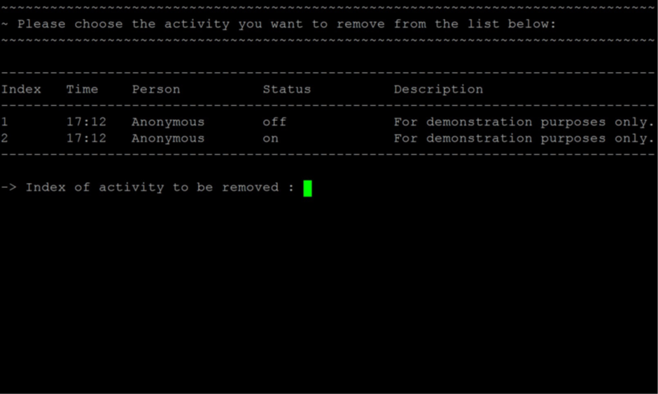

Figure . Deleting an activity: Step 3.